**Developing a Procedure**

Now that you have come up with a hypothesis, you need to develop an experimental procedure for testing whether the data collected supports or rejects the hypothesis. The first step of designing your experimental procedure involves planning how you will change your independent variable and how you will measure the impact that this change has on the dependent variable. To guarantee a fair test when you are conducting your experiment, you need to make sure that the only thing you change is the independent variable. And, all the controlled variables must remain constant. Only then can you be sure that the change you make to the independent variable actually caused the changes you observe in the dependent variables.

Scientists run experiments more than once to verify that results are consistent. In other words, you must verify that you obtain essentially the same results every time you repeat the experiment with the same value for your independent variable. This insures that the answer to your question is not just an accident. Each time that you perform your experiment is called a **run** or a **trial**. So, your experimental procedure should also specify how many trials you intend to run. Most teachers want you to **repeat your experiment a minimum of three times**. Repeating your experiment more than three times is even better, and doing so may even be required to measure very small changes in some experiments.

In some experiments, you can run the trials all at once. For example, if you are growing plants, you can put three identical plants (or seeds) in three separate pots and that would count as three trials.

In experiments that involve testing or surveying different groups of people, you will not need to repeat the experiment multiple times. However, in order to insure that your results are reliable, you need to test or survey enough people to make sure that your results are reliable. How many participants are enough, what is the ideal sample size? See the Science Buddies resource, [How Many Survey Participants Do I Need?](http://www.sciencebuddies.org/science-fair-projects/project_ideas/Soc_participants.shtml), to find out.

Every good experiment also **compares** different groups of trials with each other. Such a comparison helps insure that the changes you see when you change the independent variable are in fact caused by the independent variable. There are two types of trial groups: experimental groups and control groups.

The **experimental group** consists of the trials where you change the independent variable. For example, if your question asks whether fertilizer makes a plant grow bigger, then the experimental group consists of all trials in which the plants receive fertilizer.

In many experiments it is important to perform a trial with the independent variable at a special setting for comparison with the other trials. This trial is referred to as a **control group**. The control group consists of all those trials where you leave the independent variable in its natural state. In our example, it would be important to run some trials in which the plants get no fertilizer at all. These trials with no fertilizer provide a basis for comparison, and would insure that any changes you see when you add fertilizer are in fact caused by the fertilizer and not something else.

However, not every experiment is like our fertilizer example. In another kind of experiment, many groups of trials are performed at different values of the independent variable. For example, if your question asks whether an electric motor turns faster if you increase the voltage, you might do an experimental group of three trials at 1.5 volts, another group of three trials at 2.0 volts, three trials at 2.5 volts, and so on. In such an experiment you are comparing the experimental groups to each other, rather than comparing them to a single control group. You must evaluate whether your experiment is more like the fertilizer example, which requires a special control group, or more like the motor example that does not. Whether or not your experiment has a control group, remember that every experiment has a number of controlled variables. Controlled variables are those variables that we don't want to change while we conduct our experiment, and they must be the same in every trial and every group of trials. In our fertilizer example, we would want to make sure that every trial received the same amount of water, light, and warmth. Even though an experiment measuring the effect of voltage on the motor's speed of rotation may not have a control group, it still has controlled variables: the same motor is used for every trial and the load on the motor (the work it does) is kept the same.

A little advance preparation can ensure that your experiment will run smoothly and that you will not encounter any unexpected surprises at the last minute. You will little advance preparation can ensure that your experiment will run smoothly and that you will not encounter any unexpected surprises at the last minute. You will need to prepare a detailed experimental procedure for your experiment so you can ensure consistency from beginning to end. Think about it as writing a recipe for your experiment. This also makes it much easier for someone else to test your experiment if they are interested in seeing how you got your results.

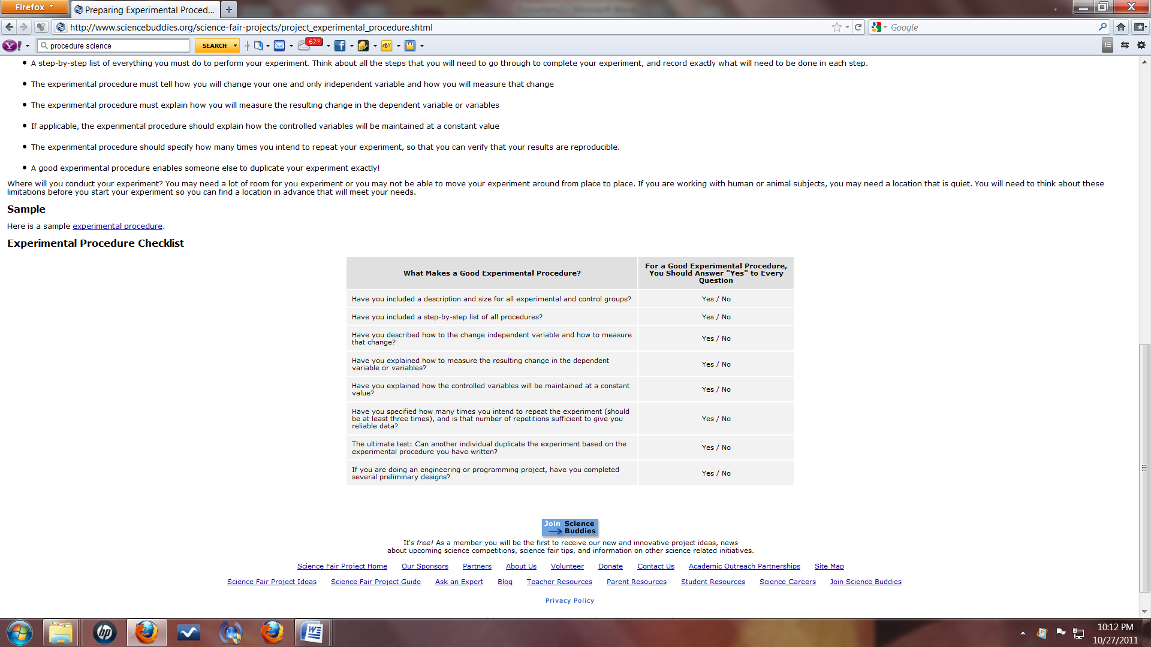

For this assignment a partnership has been created between an expert and a novice. The AP student is considered the expert because they have participated in the Science Fair and have written procedures before. The novice is the 9th grade student who is experiencing a high school Science Fair project for the first time. The expert and the novice are required to meet and develop a detailed procedure for the novice's science fair project. Both group members will be given the same grade for the final project. The grade will be worth a lab grade as well as a practice grade. The grade will be based on the following rubric. The rubric is designed to grade you on both your ability to work with other scientists (your partner) and the quality of your final procedure. Science investigations involve collaboration and this project is designed to be a mutualistic relationship between the novice and the expert! We have high expectations and know you all will meet them!

The final procedure is due to your teacher by September, 25th. It must be typed and printed out. Mr. Smith, Ms. Scudder and Ms. Butts will have their rooms available for the group to meet both before and after school. Please verify the time your group plans on meeting, with your teacher, so you can be given a pass to the classroom.

Make sure to check for....

* A paragraph at the beginning that states the hypothesis being tested.
* The experimental groups/control groups
* The size of each group and number of trials
* 5 to 7 constants
* A thorough/detailed step by step procedure in paragraph format
* A method of measuring the dependent variable that is reasonable and quantitative

|  |  |  |  |  |  |  |  |
| --- | --- | --- | --- | --- | --- | --- | --- |
|  | | Excellent (10-8pts) | | Good (7-5 pts) | | Fair (4-3pts) | Poor (2-0pts) |
| Description of experimental and control groups | | Clearly defined, logical, thoroughly described both experimental and control groups, Size of each group given | | Experimental and control groups are identified, but clearly defined. Size of each group given. | | Experimental and control groups are present but not logical or missing a major factor. Size of each group not given. | No description or lacking logical identification of groups. Size of each group not given. |
| Step-by-Step procedure | | Step-by-Step procedure is present, clear, and complete | | Step-by-Step procedure is present, easy to follow but no crucial steps are missing | | Step-by-Step procedure is present but not thorough. It could not be replicated because of lacking steps | Step-by-Step procedure severely lacking the appropriate steps needed or not present. |
| Independent Variable | | The change in the independent variable is clearly stated and appropriate for the hypothesis being tested. Detail is given to describe the differences. | | The change in the independent variable is stated and appropriate for the hypothesis being tested. Not enough detail is given to describe the differences. | | The change in the independent variable is stated and appropriate for the hypothesis being tested. Not enough detail is given to describe the differences. | The change in the independent variable is not clearly stated or not appropriate for the hypothesis being tested. No detail is given to describe the differences. |
| Dependent Variable | | Form of measurement for the dependent variable is clearly stated and appropriate. Steps are clearly outlined in the procedure. Detail is given. | | Form of measurement for the dependent variable is appropriate. Steps provided to accomplish the measurement are given but lacking some detail. | | Form of measurement for the dependent variable is not appropriate. Steps provided to accomplish the measurement are given but lacking some detail. | Form of measurement for the dependent variable is not suitable or not provided. |
| Constants | | Six to seven constants have been identified and explanation to importance has been given. Constants are reasonable factors pertinent to experiment. | | Five to six constants have been identified and explanation to importance has been given. Constants are reasonable factors pertinent to experiment. | | Three to four constants have been identified and explanation to importance has been given. Constants are reasonable factors pertinent to experiment | Two or less constants have been identified and explanation to importance has been given. Constants are reasonable factors pertinent to experiment |
| Number of trials | | Number of trials have been given and number is sufficient to collect reliable data | | Number of trials have been given and reasonable but not sufficient to collect reliable data | | Number of trials have been given but far from sufficient to collect reliable data | Number of trials have not been stated. |
| Ultimate test | | Another individual can duplicate the experiment based on the experimental procedure provided | | Another individual can duplicate the experiment with little difficulty based on the experimental procedure provided | | Another individual would have great difficulty to duplicate the experiment based on the experimental procedure provided | Another individual could not duplicate the experiment based on the experimental procedure provided |
| Group Work (2x) | | Successfully met with partner to collaborate on procedure. Equal work input and output. (met in person at least once) | | Successfully met with partner to collaborate. Good partnership. (met in person at least once) | | Successfully met with partner but times missed or work late. Unequal partnership. (met in person at least once) | Did not successfully meet with partnership unequal work input and output. |
| **Student and Mentor Information Sheet** | | | |
| **Name** | |  | |
| **Best way to contact me** | |  | |
| **Best time to meet. Please provide day of the week and time** | |  | |
| **Location and time of study skills class if applicable** | |  | |

|  |  |
| --- | --- |
| **Student and Mentor Information Sheet** | |
| **Name** |  |
| **Best way to contact me** |  |
| **Best time to meet. Please provide day of the week and time** |  |
| **Location and time of study skills class if applicable** |  |

|  |  |
| --- | --- |
| **Student and Mentor Information Sheet** | |
| **Name** |  |
| **Best way to contact me** |  |
| **Best time to meet. Please provide day of the week and time** |  |
| **Location and time of study skills class if applicable** |  |

|  |  |
| --- | --- |
| **Student and Mentor Information Sheet** | |
| **Name** |  |
| **Best way to contact me** |  |
| **Best time to meet. Please provide day of the week and time** |  |
| **Location and time of study skills class if applicable** |  |

|  |  |
| --- | --- |
| **Student and Mentor Information Sheet** | |
| **Name** |  |
| **Best way to contact me** |  |
| **Best time to meet. Please provide day of the week and time** |  |
| **Location and time of study skills class if applicable** |  |

|  |  |
| --- | --- |
| **Student and Mentor Information Sheet** | |
| **Name** |  |
| **Best way to contact me** |  |
| **Best time to meet. Please provide day of the week and time** |  |
| **Location and time of study skills class if applicable** |  |